# Experience Map

In this section, the experience map for the problem is shown. This map shows the whole experience of someone with diabetes, since before the diagnosis, and passing through his/her whole experience with diabetes. This map was created based on interviews, questionnaires and observations made with seniors with diabetes. The experience map showed below has five different sections: *Entice, Enter, Engage, Exit, Extend.* Each of these sections has some attributes related to the section.

# Entice

In this section is found the causes that bring seniors to diabetes. These are what called their attention and the main causes for their problem.

## Sugar Desire



Image 1: [consciouscooking.com](http://consciouscooking.com) Image 2: [images6.fanpop.com](http://images6.fanpop.com)

Usually, before being diagnosed with diabetes, the senior was used to have a non-health diet. The desire for sugar is one of the major causes for the diabetes.

## Failing the promise of returning to a health lifestyle

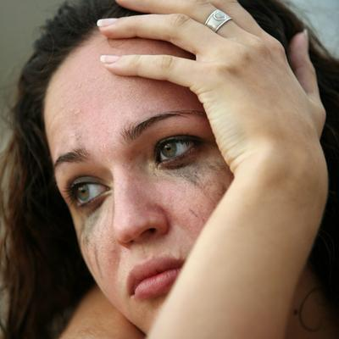

Image 3: img2.timeinc.net

The seniors usually made promises before being diagnosed, but they have never been able to fulfill them.

# Enter

In this section is found the beginning of their lives within diabetes.

## Diagnosishemochromatosis-diagnosis.jpg

Image 4: hemochromatosisdna.com

The diagnosis is the entrance mark for their lives with diabetes. After being diagnosed, a lot of changes in their lifestyle occurs.

## Habit changes

## Changing.jpg

Image 5: lifestyleupdated.com

A big amount of changes occurs in the daily life after being diagnosed with diabetes. Since diet changes until the need of exercise, any change is made in order to get better life conditions.

## Training



Image 6: [designvisionaries.com](http://designvisionaries.com)

Due to big amount of habit changes, people diagnosed with diabetes need trainment to correctly use the monitors, or to correctly follow a good lifestyle. Sometimes this trainment step do not occur, with can cause trouble for the patient.

# Engage

In this section is found what occurs during their lives within diabetes.

## Symptoms

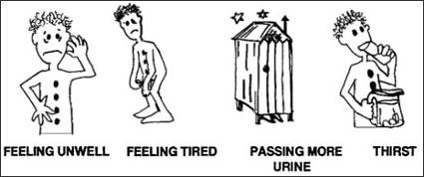

Image 7:wikieducator.org

During their whole live with diabetes, usually they will suffer some symptoms and need to take the exactly medicine to deal with that.

## Doctor visits



Image 8: tricare4u.com

Frequently, the person managing his/her diabetes will need to learn to self-manage. However, the presence of a doctor is not avoided. Usually, consults with doctors will occur to make sure that everything is being done right.

## Good lifestyle



Image 9: med-health.net

Keeping a good lifestyle will be always necessary to avoid trouble for a diabetic. A good lifestyle can decrease the number and the frequency of the symptoms.

## Using monitors

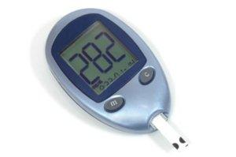

Image 10: raw-food-health.net

Usually, the person managing his/her diabetes will need to use some monitors to guide him/her in the management. These devices are essential for their lives because of the importance in knowing the real glucose levels.

# Exit

In this section is found the experience of exiting the self diabetes management life.

## Abandonment of devices

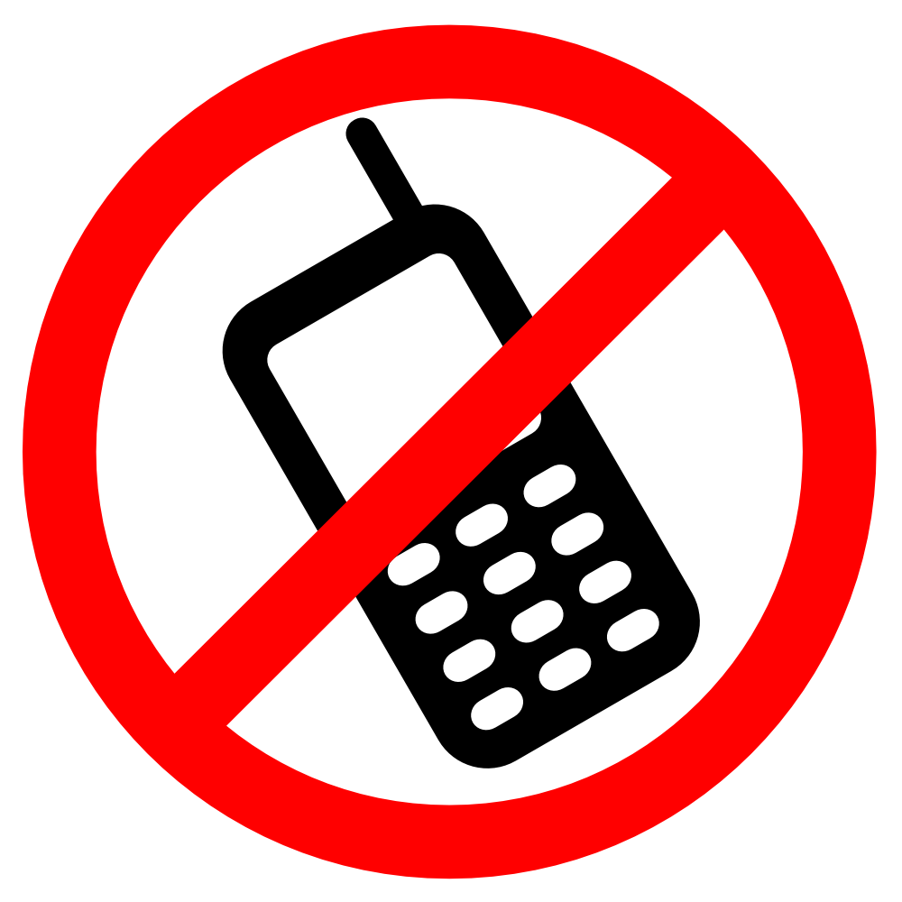

Image 11: images.onlinelabels.com

Diabetes is a problem for the whole life. Because of that, when one device becomes unnecessary, it is considered more freedom for the patient, which is an exit proccess of the diabetes.

# Extend

In this section is found anything that can help the patient after the exit step. Anything that can keep the safeness of his/her health condition.

## Doctor’s accompaniment

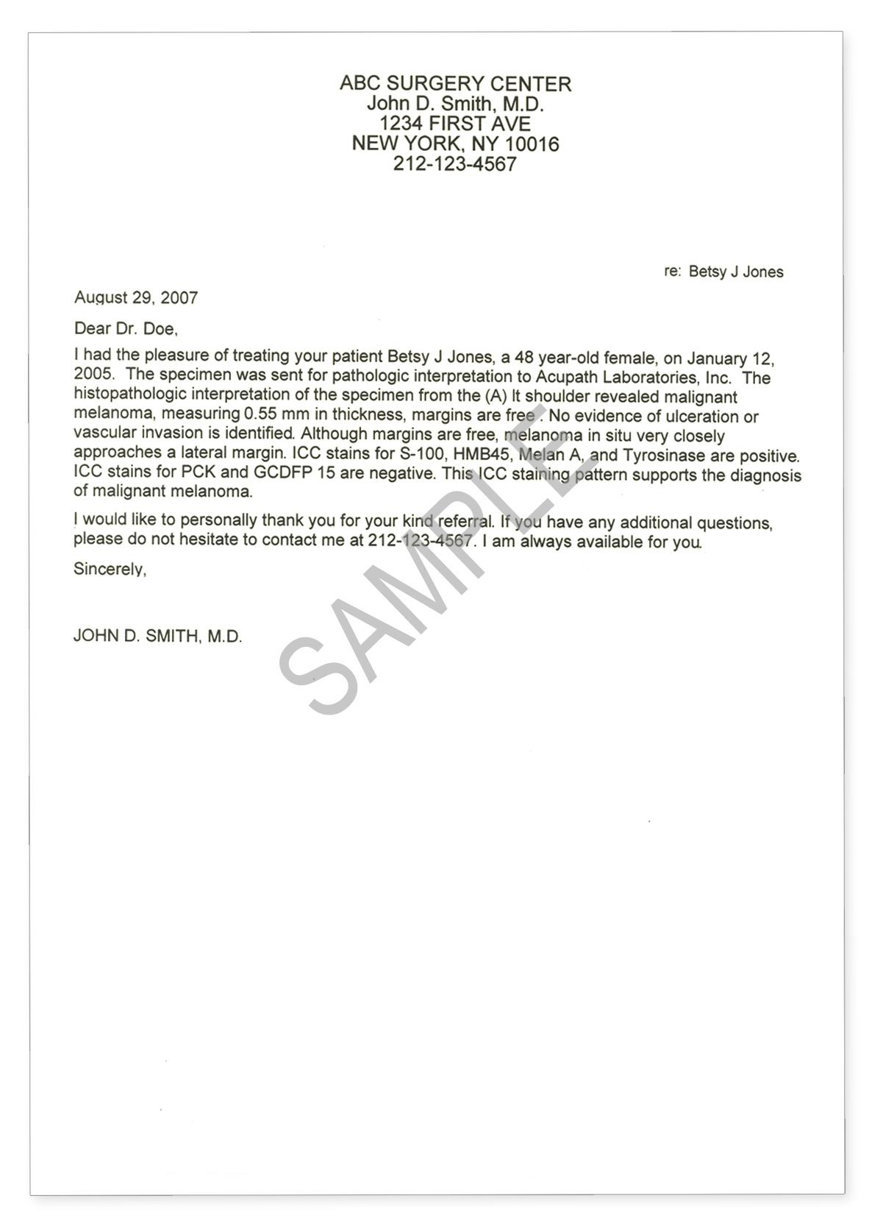

Image 12: acupath.com

The doctors will still maintain contact with their patient to make sure that they are having a health life without any trouble.

## Feeling better due to their success



Image 13: quickanddirtytips.com

Having success in their diabetes self management makes them emotionally better, which is good for their health as well.

# Conclusion

This experience map showed the whole experience of a patient suffering from diabetes. By using this map, we can understand the steps with issues and try to give a solution to them.